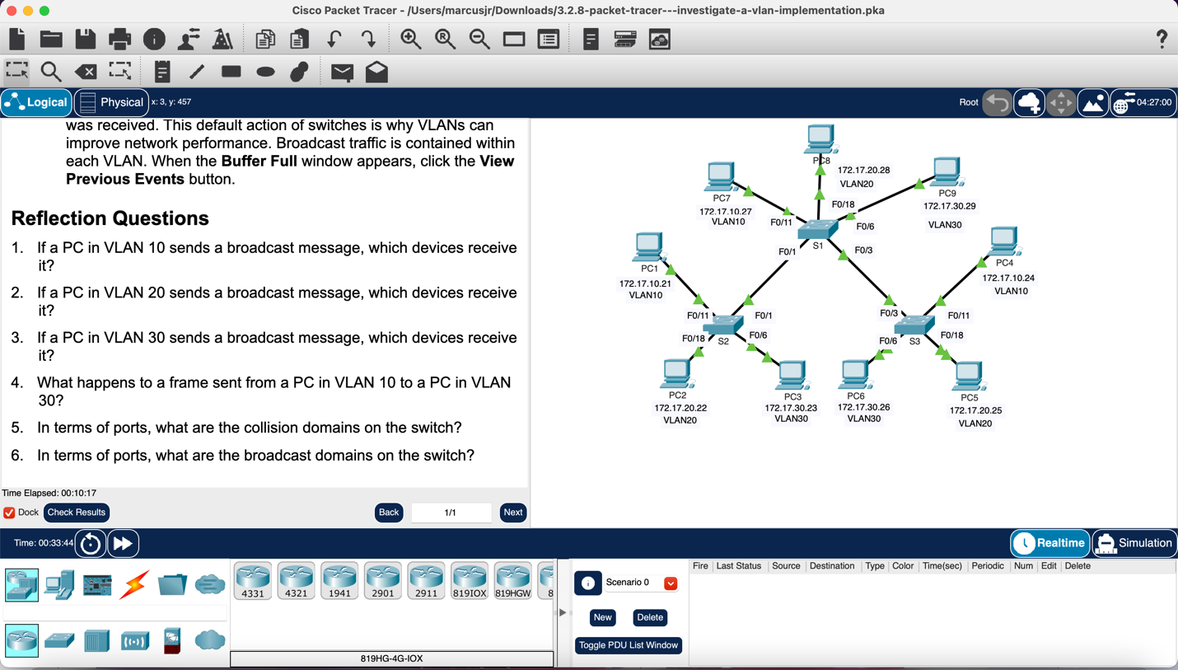

1. VLAN 10 devices
2. VLAN 20 devices
3. VLAN 30 devices
4. It will be lost because the message is coming from VLAN 10 and can not go to VLAN 30
5. Each port is a separate collision domain
6. VLAN 10, 20, and 30 so there are 3 broadcast domains

